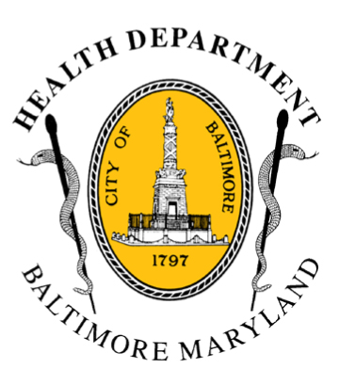
BCHD PRESS RELEASE
Baltimore City Health Department
1001 E. Fayette Street • Baltimore, Maryland 21202
Stephanie Rawlings-Blake, Mayor
Leana Wen, M.D., Commissioner of Health

FOR IMMEDIATE RELEASE

Media Contact:

Jennifer Fuson O: (410) 545-0823 E: Jen.Fuson@baltimorecity.gov
Baltimore Announces $8.5 Million Dollar HHS Grant to Implement Reproductive Health Education Program in Middle and High Schools

Program Aims To Reduce Teen Births by Thirty Percent Over Five Years

BALTIMORE, MD (July 27, 2015) – The Baltimore City Health Department and the U Choose Coalition have been awarded a $8.5 million grant with a goal of decreasing the city’s teen birth rate for African American and Hispanic girls by 30 percent. The grant, from the U.S. Department of Health and Human Services, is for $1.7 million dollars per year for five years.

The project includes a partnership with the Baltimore City Schools, Planned Parenthood of Maryland, Johns Hopkins University Center for Adolescent Health, Healthy Teen Network, Family League of Baltimore, Gay, Lesbian and Straight Education Network, Behavioral Health System Baltimore, and a network of seven Title X clinics.

“We are so proud to announce the commitment of federal dollars toward educating Baltimore’s youth about reproductive health. The grant attests to the leadership the city has shown in reducing teen pregnancy and births, and will also will let us continue with the work that is needed for Baltimore women to thrive,” said Mayor Stephanie Rawlings-Blake.

“We know unintended teen pregnancy and parenting is the number one reason that young women do not complete high school, which often results in a continued cycle of poverty, unemployment, and worse health for the mother and child,” said Baltimore City Health Commissioner Dr. Leana Wen. “That is why one of Baltimore’s top public health priorities is reducing teen pregnancy through comprehensive education for our youth.”

- more-

2-2-2

The funding will be used to implement a comprehensive reproductive health curriculum in middle schools, high schools, and Title X clinics targeting vulnerable populations concentrated in neighborhoods that have high poverty and infant mortality rates. Baltimore’s teen birth rate (43.3 per 1,000 teen girls) is 1.5 times higher than the national rate and twice as high as the state of Maryland.

Baltimore’s teen pregnancy programs have helped reduce the birth rate for teenagers (age 15 - 19) by an unprecedented 32 percent between 2009 and 2013. However, there remains need for health education; four out of ten high school students attend schools not meeting national standards for health education. The Baltimore City Health Department will use the federal funding to help close the gap by implementing proven evidence-based programs.

These include:
- Implementing Project AIM (Adult Identity Project) in sixth and seventh grades in 86 public middle schools, reaching more than 8,500 students, focusing on helping youth envision a future as a positive adult by increasing school connectedness and attendance.
- Be Proud! Be Responsible! curriculum to educate approximately 4,000 high school students on teen pregnancy and condom use.
- Expanding the U Choose initiative that improves access to youth-friendly services at Title X clinics and empowers youth through the KnowWhatYou Want social marketing campaign.
- A program in Title X clinics called Seventeen Days (17 Days) to enable sexually active females to rehearse sexual negotiation skills in private settings.

“This grant will enable us to increase programming that, ultimately, will keep more students in school--and will promote those students’ physical, emotional, and social well-being,” said Dr. Gregory E. Thornton, Chief Executive Officer, Baltimore City Public Schools. “We are looking forward to working with the project partners to implement curriculum that promises to have a real and positive impact on our students’ futures.”

“This grant would not have been made possible without the dedication and commitment of the city’s public schools, community groups, health clinics, and strong teen pregnancy prevention programs already in place in Baltimore like U Choose,” said Dr. Wen. “We want all young people in our city to have the resources they need to reach their highest potential, to be able to finish school, and to support their own family when and if they choose to have children.”

By the end of the five-year project Baltimore plans to reach approximately 16,000 adolescents aged 12-19 each year to reduce disparities among teen birth rates between African American and Hispanic teens.

###

